|  |  |
| --- | --- |
| 78332599 | http://www.irla.cn/en/archive |

Go to the website using above url you will get page like below

Need both non roman and English toc

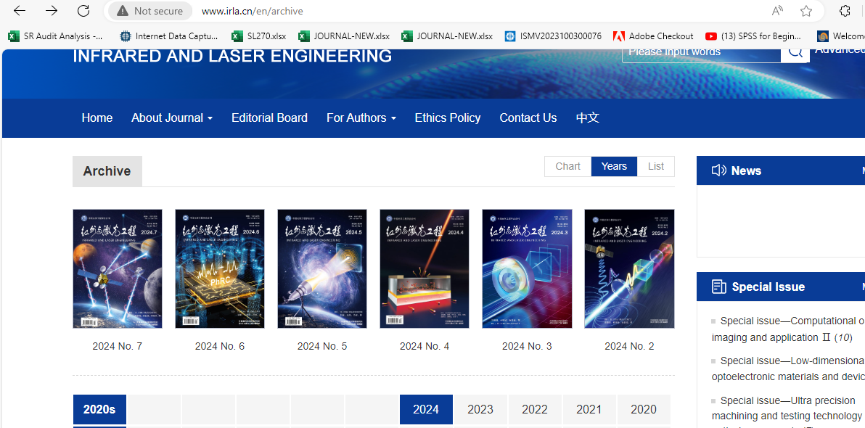

Select the latest issue

You will get the latest issue page like below.

Download pdf

Captutre identifier

Issue

Year

Volume

Article title

Captutre DOI